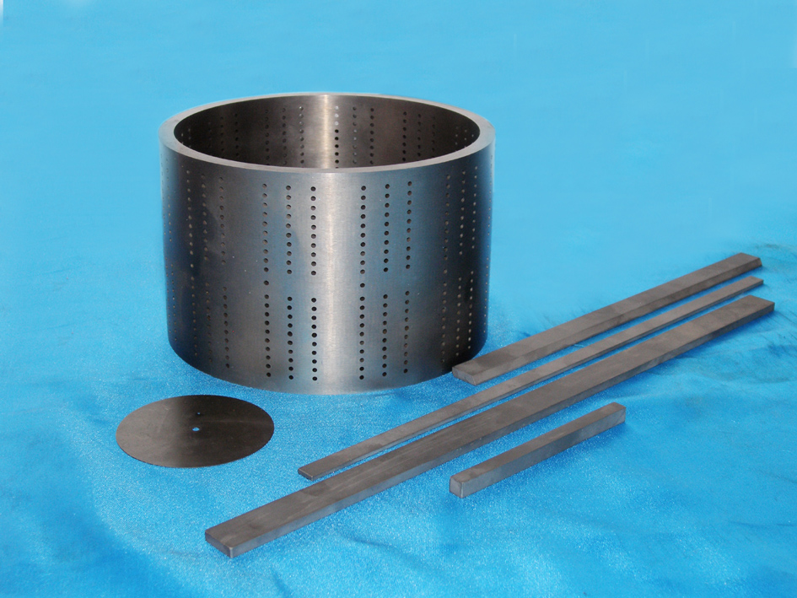
烟机零件 tobacco machine parts
- 切纸刀、刮削刀
- 带有720个φ2 mm小孔的硬质合金薄壁筒
- 各种导板、导轨、导轮、铲刀
- paper-cutting tools 、 scrapping tools
- Carbide sleeve with thin walls with720 holes with
diameter of 2mm.
- Various guide plates, guide ways, guide wheels
and shovel blades.

